**DEPARTMENT OF ELECTRONICS & COMMUNICATION ENGINEERING**



Embedded System

**Experiment-12**

**­­**

**Submitted by**

**PRATIBHA SINGH**

**602162015**

**M.Tech (VLSI Design)**

**­­­**

**Experiment 12**

**Aim:**

To write an ARM Assembly Language to find the number of times a character is repeated in a string.

**Tool Used:**

Keil uVision4

**Theory**:

DCD stands for Define Constant Double word and DCB stands for Define Constant Byte. The value of the string is loaded using DCB and DCD values and compared until the value is 0.

**Code:**

    AREA PROGRAM, CODE, READONLY

    ENTRY

MAIN

        LDR R0, VALUE1

        MOV R1, #'D'

LOOP2   LDRB R3,[R0],#1

        CMP R3,R1

        BNE LOOP2

        ADDS R3,R3,#0

        BEQ LOOP1

        ADD R7,R7,#1

        B LOOP2

LOOP1   SWI &11

    AREA PROGRAM, DATA, READONLY

VALUE1 DCD STRING

STRING DCB "EMBEDDED"

    END

**Output:**

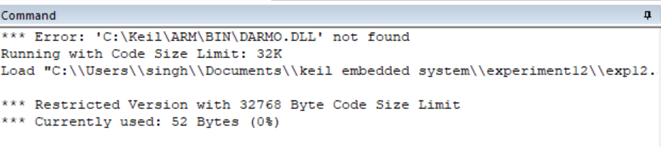

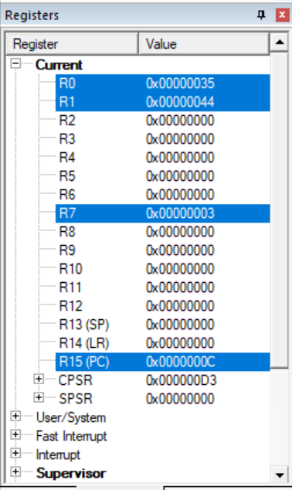

The word Embedded has 3 D in it which is displayed in R7.

**Result:**

The experiment to find the number of times a character is repeated in a string has been performed and verified to be correct.